Winchcombe – Belas Knap- Winchcombe
14k
Some hills

Park at the library, walk to the back of the car park and turn right into Cowl Lane. When you meet the High Street turn right and continue past the Abbey Terrace car park. Turn left into Vineyard St observing the quaint Cotswold houses on both sides of the street. Walk down and over the bridge and take the first waymarked path on the right (through stile). Follow the path directly across the fields until it brings you to opening onto Corndean Lane. Turn left and walk up the road for approx. 100 metres. Turn right into the Cricket Ground and follow the drive up past the cricket pitch. Continue until you see a waymarked stile on your left. Follow the path and waymarked points up and across the field (this is quite a long drag uphill but worth it. Stop for a breather and look back across Winchcombe.
. 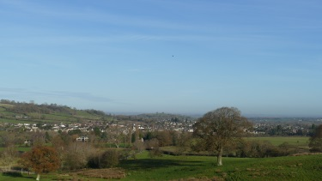 At the top, cross the stile and walk over the road to the footpath opposite which takes you through a small wood. Follow this path along and up. Cross the top stile and turn left. Follow the well walked path along and around the edge of the field. Continue along the path through a wooded area until you reach the Long Barrow of Belas Knap. Stop a while and explore the ancient burial ground . When you are ready to continue, cross over the next stone stile opposite and continue along the side of the field. When you reach the end of this field , walk out onto the road/track and turn left. This is a long track with walls either side . On the right is the famous Cleeve Common on Cleeve Hill (highest point in the Cotswolds). Continue walking along the track and down to Wontley Farm (derelict farm buildings) . At this point turn left and walk down the field to the side of the barns. When you get to the bottom continue through the wood bearing right until you come to a tarmac road. This road is the only access to the house that you are going to walk past. Follow this road, look out for the unusual cottage on your right
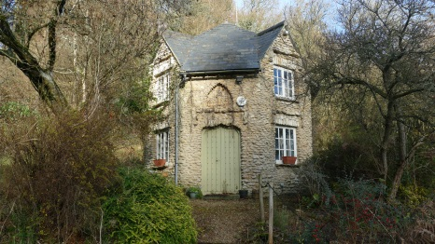

This road now continues for approx. ½ mile where you will come to a cross roads. Cross directly over and continue. Take the next lane on your left and walk until your reach the small village of Charlton Abbots. On your left you will see the large manor house. The footpath is on your right and is the path down to the village church. Be careful as this can be slippery. Take this chance to have a look around the churchyard
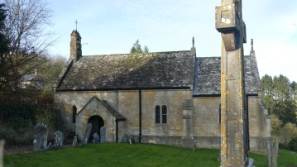
Cross over the stile by the church and take the path diagonally down the field until you reach the brook. Cross the brook (can be muddy) and over the stile on the other side. The footpath goes left here but you may have to bear right to walk around the marshy ground which is very wet. Return to the footpath and follow the hedge line along the bottom. Follow the waymarked path along the hedge line until you will come out another batch of farm buildings (waterhatch). The walk then takes you left but take a while to explore the waterhatch and the old mill wheel, mill pond and old pig stys.
Pick the track and continue through a gate. The track continues until your reach the tarmac road and small collection of farm buildings and cottages. You are now on the “old Brockhampton Road”. Follow this road all the way back to Winchcombe. If you look out to your right you will have a great view of Sudeley Castle.
Follow the road left at the castle entrance and you are at the end of your walk and back in Vineyard Street

